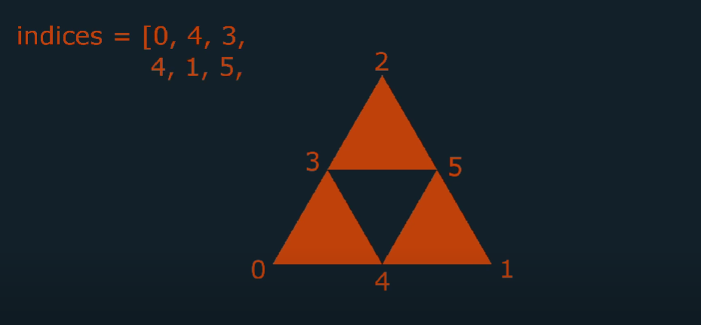

What if we need to create a triangle like this

In this case we need index buffer

Skipped for now

If needed visit : <https://www.youtube.com/watch?v=KG9ZXKaJWwY&list=PLPaoO-vpZnumdcb4tZc4x5Q-v7CkrQ6M-&index=4>